**FreshMart Sales Insights Dashboard Documentation**

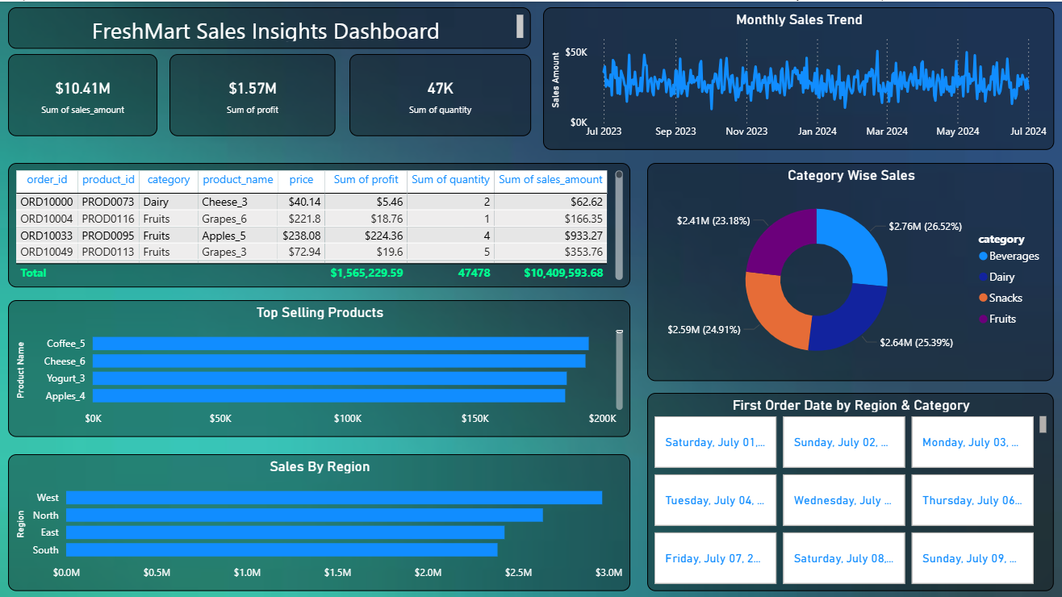

**Project Objective**

To design an interactive Power BI dashboard that provides a comprehensive overview of FreshMart’s sales, profit, product categories, and regional performance. The goal is to assist stakeholders in understanding business trends, product performance, and customer behavior**Tools & Technologies Used**

* Microsoft Power BI
* Microsoft Excel
* DAX

**Key Features & Visuals**

**KPI Cards**

* Total Sales: $10.41M
* Total Profit: $1.57M
* Total Quantity Sold: 47K

**Monthly Sales Trend**

Line chart showing sales trends from July 2023 to July 2024, identifying peak months and sales fluctuations.

**Category-Wise Sales Distribution**

Donut chart showing sales contribution by category:

* Beverages: $2.76M (26.52%)
* Dairy: $2.64M (25.39%)
* Snacks: $2.59M (24.91%)
* Fruits: $2.41M (23.18%)

**Top Selling Products**

Horizontal bar chart ranking products like Coffee_5, Cheese_6, Yogurt_3, and Apples_4 by total sales amount.

**Sales By Region**

Regional comparison of total sales with West being the top-performing region followed by North, East, and South.

**First Order Date by Region & Category**

Matrix card visuals showing the first order date across regions and categories.

**Detailed Data Table**

Includes Order ID, Product ID, Category, Product Name, Price, Profit, Quantity, and Sales Amount.  
Summarized totals for each metric at the bottom.

**Business Insights**

* Identify high-revenue and high-profit products
* Understand regional performance differences
* Analyze seasonal trends in sales and customer demand
* Measure category contribution and optimize stock or marketing
* Enable better forecasting and decision-making based on sales patterns

**Impact**

* Track overall business performance in real-time
* Make informed strategic decisions in product planning
* Optimize marketing and inventory for different regions and categories
* Enhance profitability by focusing on top-performing products and areas